|  |
| --- |
| MAULANA AZAD NATIONAL INSTITUTE OF TECHNOLGY, BHOPAL  MANIT-LogoDepartment of computer science and engineering |
| Artificial Intelligence |
| Project Report  “Rubik Cube Color Detection & Solving Assistant” |
|  |
| FACULTY COORDINATOR : Dr. Mansi Gyanchandani |
|  |

**Submitted By:**

Shubham Bairagi 151112217

Shivam Rathore 151112219

Ankit Kathait 151112289

Vedant Sharma 151112292

Mausam Jain 151112309

**Abstract**

Rubik’s Cube is probably one of the most sought after toy for most of the people with a problem solving attitude and is definitely the one that helps to build the problem solving attitude in a novice.

When you start solving a jumbled Rubik Cube you have before you a whooping combination of 43*1018 (43 Quintillion) different patterns. Now, it is not easy for everyone to stand alone against this great number of combinations and solve the Rubik Cube all the way down to its required state. While a standard Rubik Cube is of size 3*3 with 6 different colors on it, there are many variants for it and now-a-days even Rubik Cubes of different dimensions are available which makes solving it more interesting.

Our goal is to assist the Rubik cube solver to solve the cube by getting input, the six faces of the cube.

**Rubik’s Cube Solver**

**Objective**

Using Image Processing to detect the colors of Rubik’s Cube, and then solving it step by step

**Introduction**

Rubik’s Cube is a 3D combination puzzle invented in 1974 by Hungarian Sculptor and professor of architecture Erno Rubik. The original name of the cube was magic cube. On the original classic Rubik Cube with 6 faces covered by 9 stickers, each sticker was of one of the following colors: Red, Green, Blue, Orange, White, Green, and Yellow. White is opposite Yellow, Blue is opposite Green and red is opposite orange. An internal pivot mechanism enables each face to turn independently thus mixing the colors. For the puzzle to be solved, each face must have only one color.

There are about 43 Quintillion different patterns (1018) of it. Many algorithms are designed to transform a scrambled Rubik Cube to the solved state. Many algorithms are designed to transform only a small part of the cube without interfering with other parts that have already been solved so that they can be applied repeatedly to different parts of the cube until the whole is solved. With about 35 CPU-years of idle computer time donated by Google, a team of researchers has essentially solved every position of the Rubik's Cube, and shown that no position requires more than twenty moves.

Now, our project aims to build a Rubik’s Cube Solver such that it can guide the person by giving him the exact move he need to make which will ultimately result in a solved cube.

**Proposed Methodology**

We will extract the colors from all the faces of the Rubik’s Cube using the camera frame by frame, and face by face by applying the Edge detection and the color detection techniques. Once the orientation and color patterns of each faces are recognized, we will aim at generating the step by step solution for the provided scrambled Rubik’s cube, using the dedicated algorithm for solving the cube.

We will follow the Layer by Layer approach in solving the cube, and not messing up with the pieces already in place. The output will be the list of steps to be followed to solve the cube puzzle. The output will be represented in form of the universal notations used to denote the rotations of faces of cube, along with the digital images of the cube orientation after each step.

**Instructions**

* Scan all the faces of the cube in the camera in such a way that the adjacent Orientation of the cube remains same. i.e. If we are scanning Red Centred Face, then the bottom face must be the White Centred face.

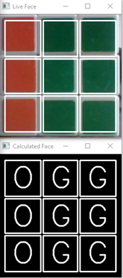

* And As the Colours detected in matches the real input, press ‘S’ to store the Face, ‘Q’ to exit the screen.

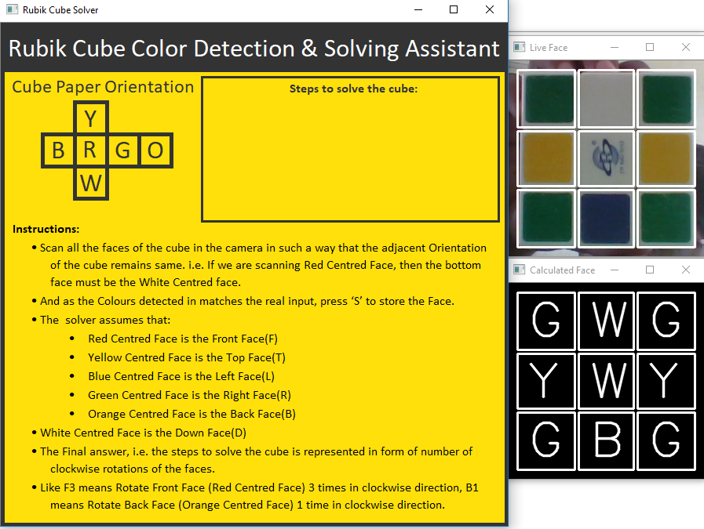

* The solver assumes that:
  + Red Centred Face is the Front Face(F)
  + Yellow Centred Face is the Top Face(T)
  + Blue Centred Face is the Left Face(L)
  + Green Centred Face is the Right Face(R)
  + Orange Centred Face is the Back Face(B)
  + White Centred Face is the Down Face(D)
* The Final answer, i.e. the steps to solve the cube is represented in form of number of clockwise rotations of the faces.
* Like F3 means Rotate Front Face (Red Centred Face) 3 times in clockwise direction, B1 means Rotate Back Face (Orange Centred Face) 1 time in clockwise direction.

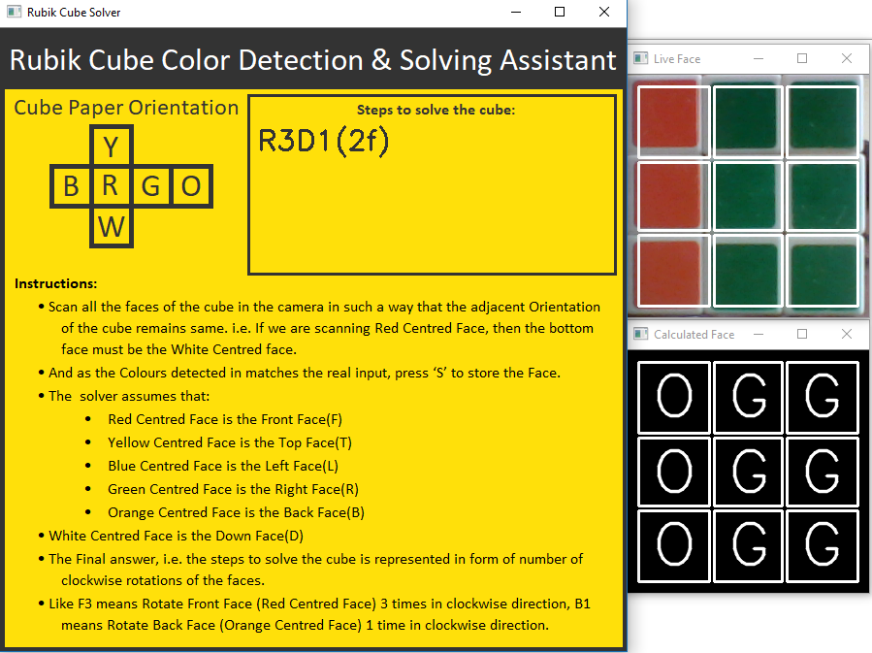

**Outcome and Accuracy**

Steps to be followed to solve the Rubik’s Cube using the images of the faces of the cube captured by the camera. The Outcome depends on various factors like surrounding light, camera quality, and handling of the cube. If all the factors are accounted for, then the results would be perfect.